On February 15, 2005, NDTA San Joaquin Chapter's Annual Membership Drive Meeting hosted speaker Earl Boyanton, jr, Asst. Deputy Under Secretary of Defense Transportation Policy at our annual Christmas Dinner at the Commercial Exchange Club Port of Stockton.

The meeting sponsored by Pilot Air and Green Valley Transportation was a lively affair. All quests were served a scrumptious and sensible dinner and the evening was both informative and fun. For those who were not there and missed it, or for those who were there and missed it, here are some images captured by our roving photographer.

Please enjoy!

Guest of Honor

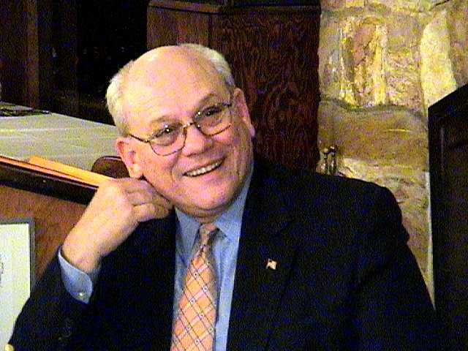
Earl Boyanton, jr. Deputy Under Secretary of Defense Transportation Policy

Honored Guests

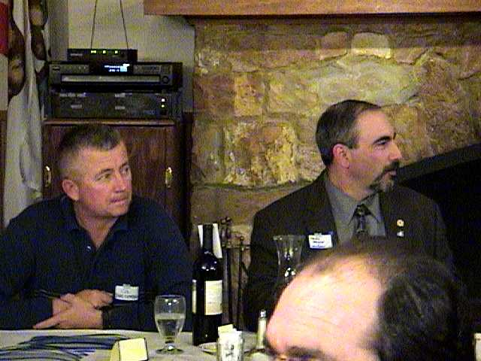
Col Douglas Serrano, Commander DDJC and Honor Guest!

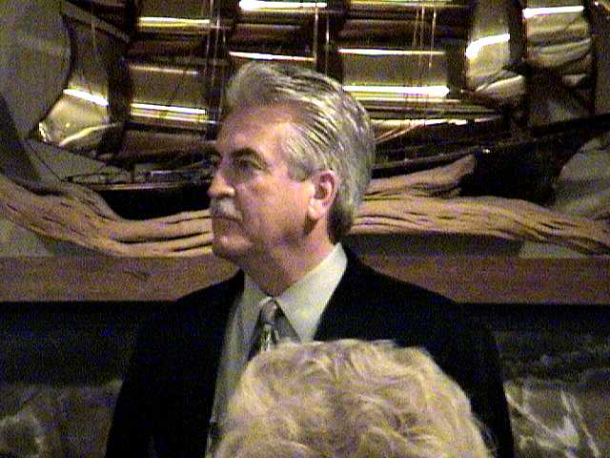

Joe Buckley, Yellow Transportation

Not just a suit. Joe served as President of our San Joaquin Chapter 05, but you got to admit it's a nice suit...trust me.

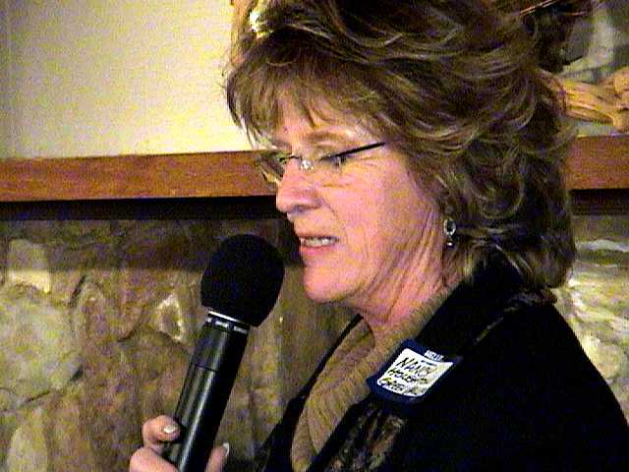
That's Nancy, our Designated MC and Welcome Wagoneer. She keeps the show moving along

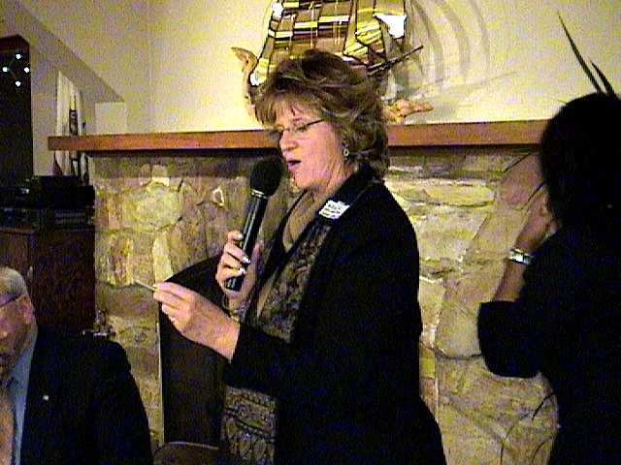
Oh my the way Nancy, we love you’re the hat...it's so Art Deco!

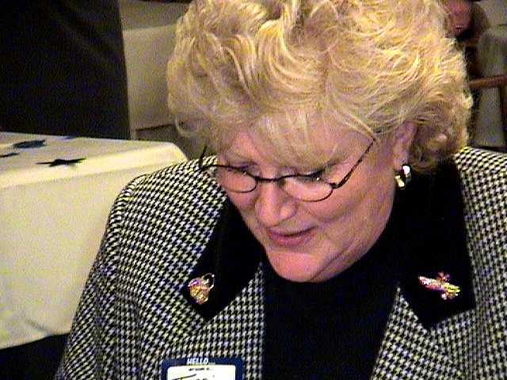

Hey this is one of the hardest working ladies at our San Joaquin Chapter and currently our acting President, Class of 2006. She’s the glue that keeps us all together. Gotcha Teri Dalton. Checking those lists, going to see who's naughty or nice...
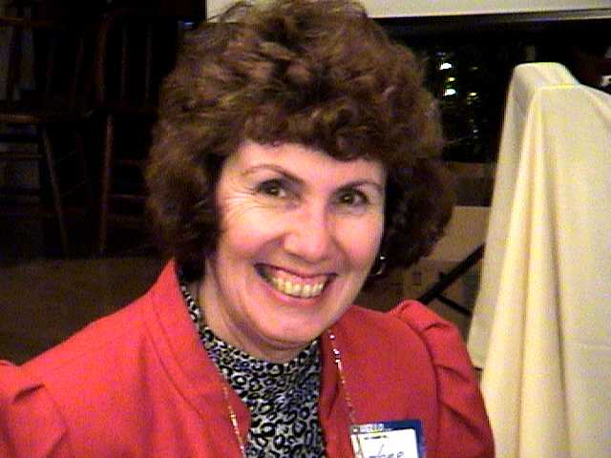

And speaking of hard working ladies. Marlene Jetton has a lot to smile about. She sells the "Be Jesus" out of those raffle tickets that helps raise money for our scholarship fund.

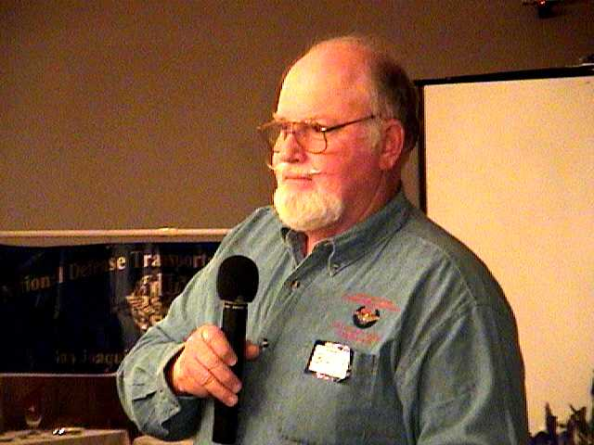
Now this guy is strictly a numbers man. And if you get the right numbers you walk away with the prise cash! Ben Jetton does a great job for us, Thanks!
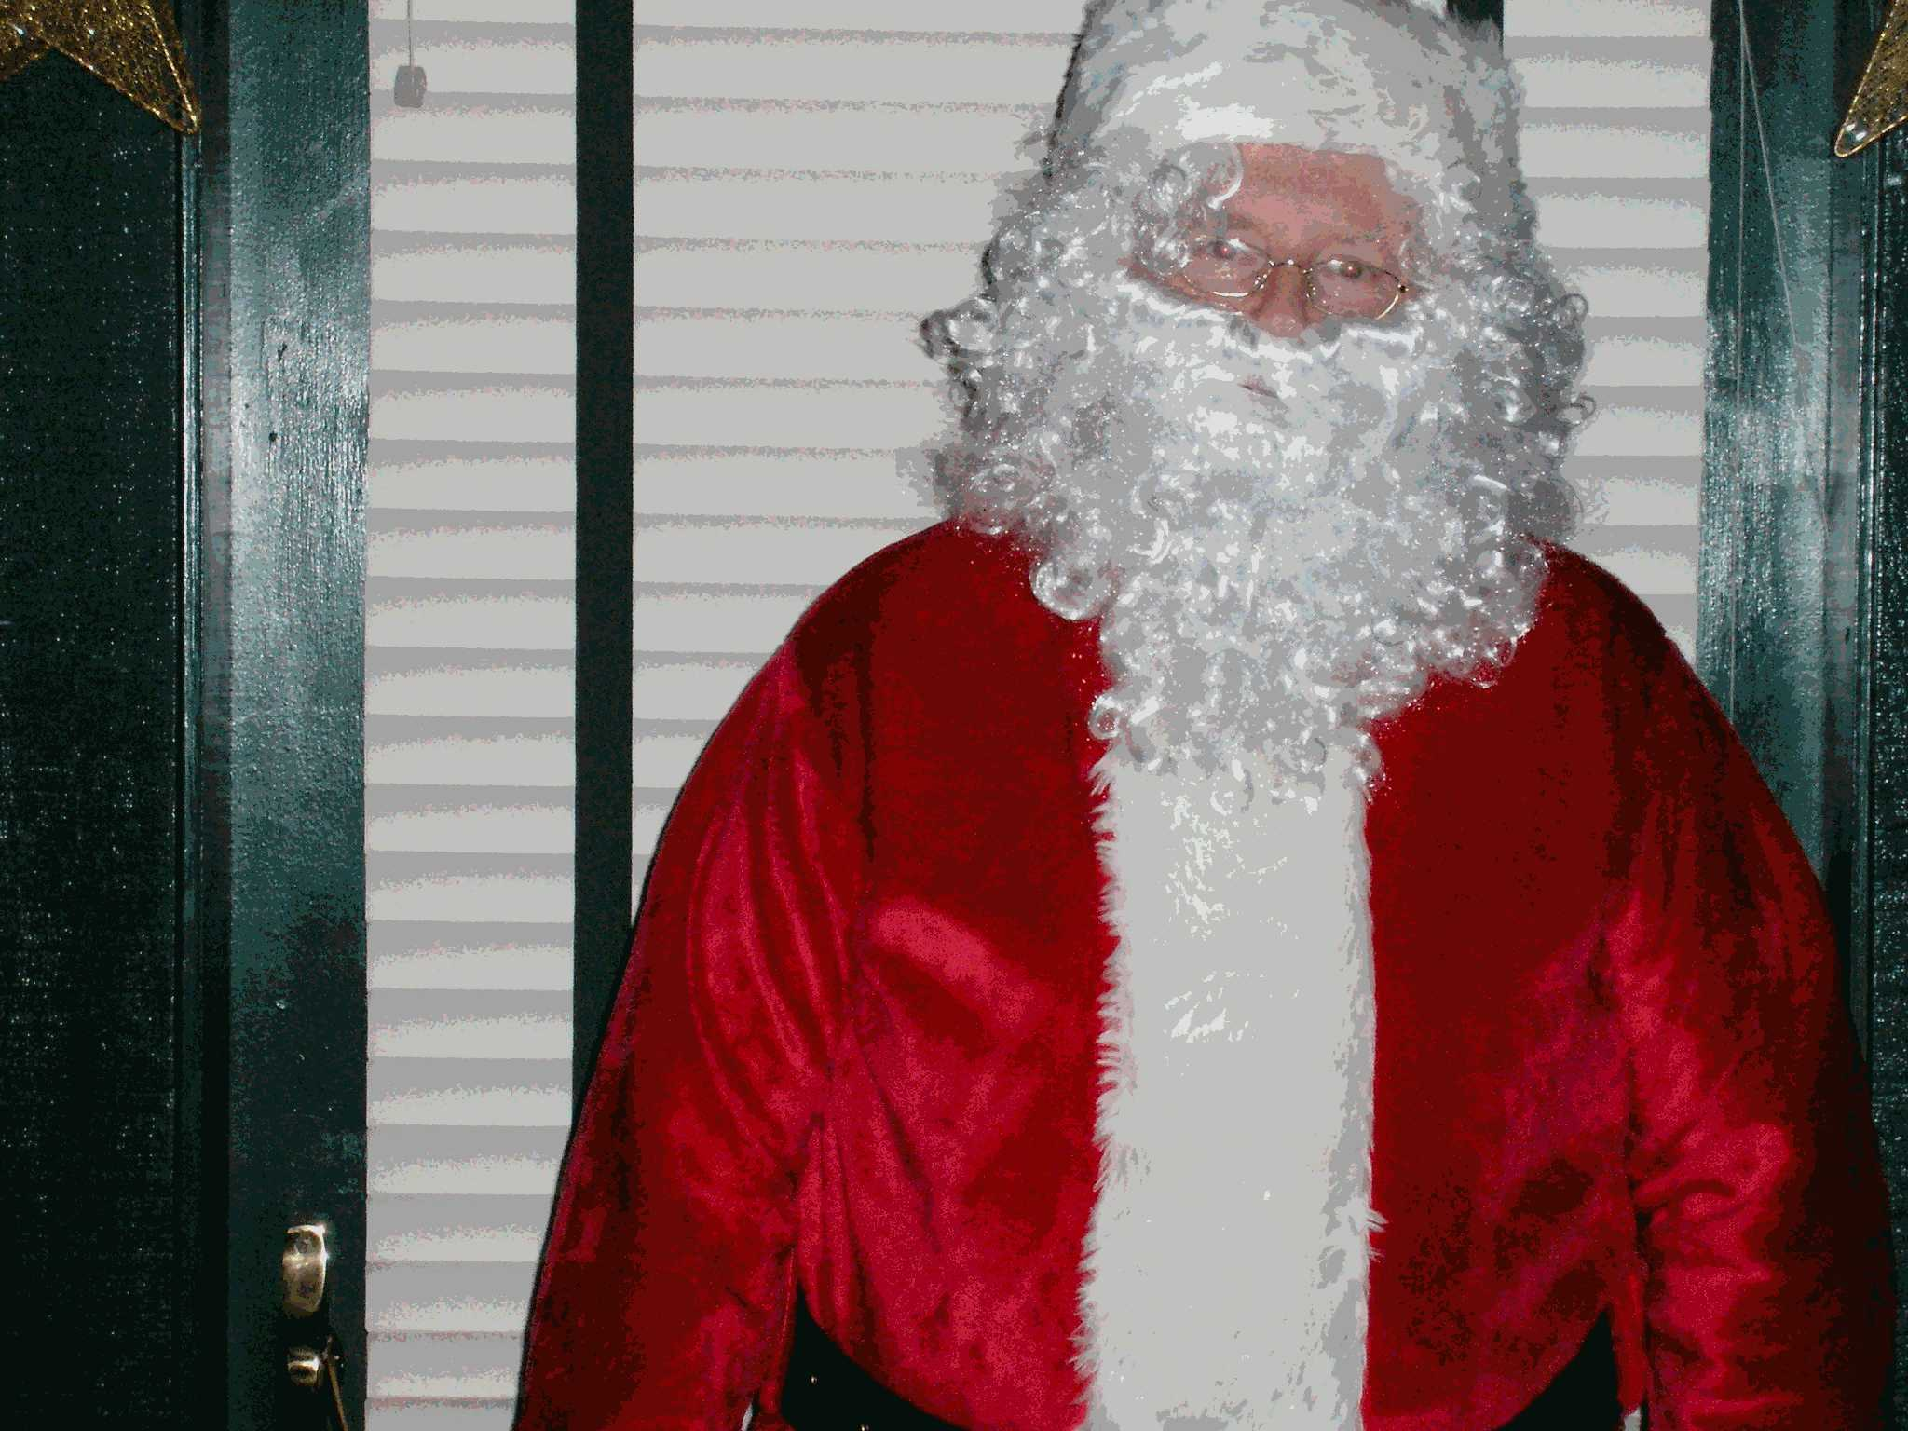
And when Ben’s not dishing out the numbers, he's handing out the toys for tots! Tell me that the suit doesn't make the man!!!!

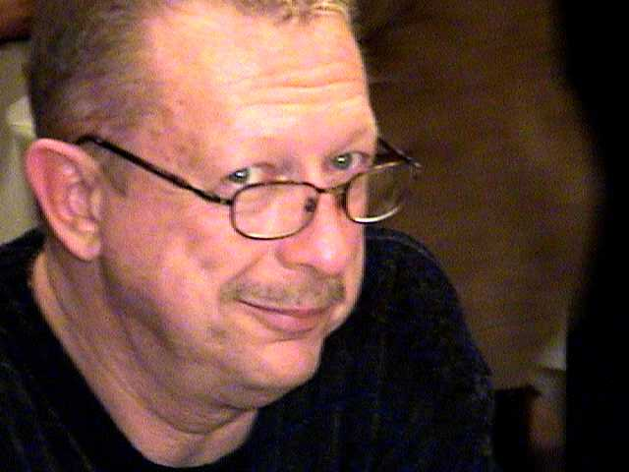
This man is so sexy, that the fish stop swimming when he walks into the room! Hi Gene Maier. Gene’s our new Vice President this year 2006.
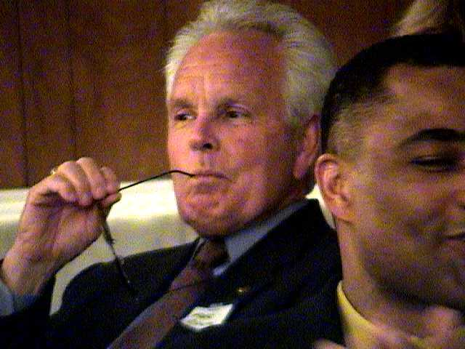
You can fool some of the people all of the time and all of the people some of the time, but you can't fool this guy any of the time. Word is out that even E F Hutton listens, when he talks.

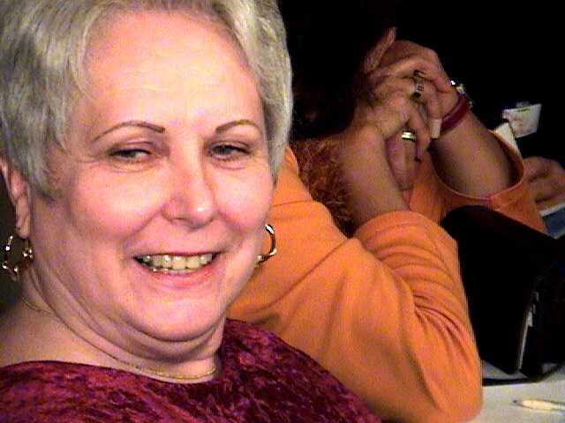
Why don't you come up to a NDTA Meeting and See me Sometime!!!!!????? Talk about Sexy! Now that’s an offer that you should never refuse.
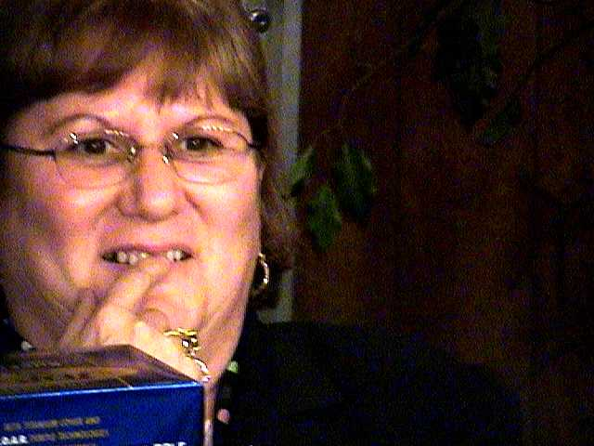
Chris Coley knows, It's no secret if you attend our NDTA.Monthly Meeting......Our speakers are informative and experts with lots of experience in the transportation business.

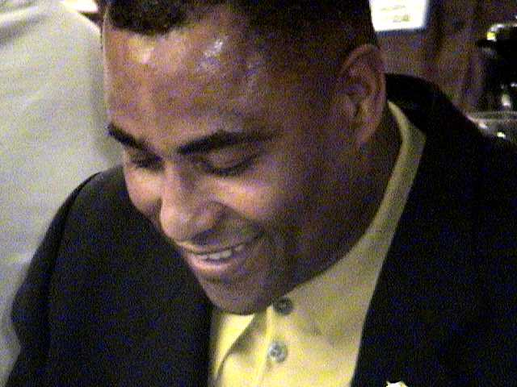
And after the speaking is over, you know we conclude our evening by check those raffle numbers for those lucky numbers!

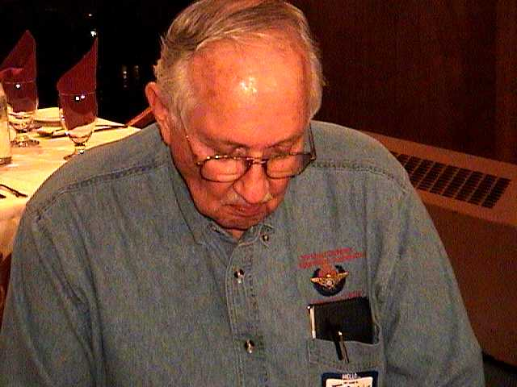
Ok if this five was a four and this three was a two and this two was an one, this ticket would be a Grand Prize winner. Darn, "Just Missed".

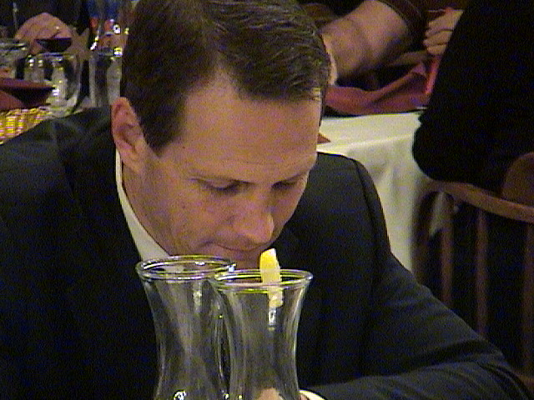
And not all the raffle tickets are lemons.
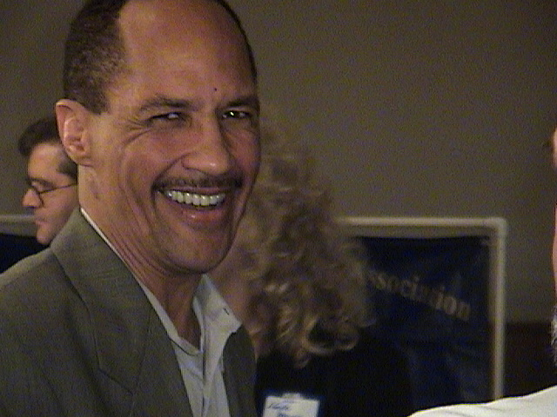
Just ask this winner!

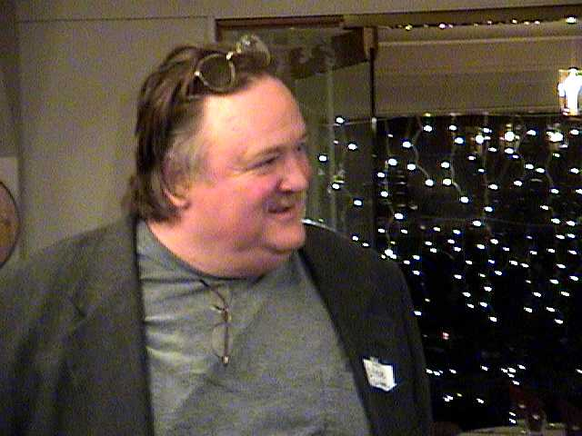
I encourage all to come out and join us at our local chapter and meet the stars who work behind the scenes, like Mr. Steve Groves, from Green Valley
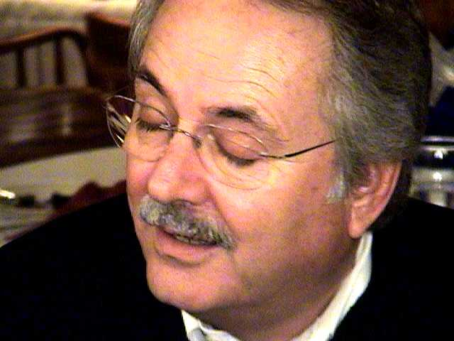
And don’t be bashful, helping others with the money we raise gives us that warm fuzzy serene feeling inside.

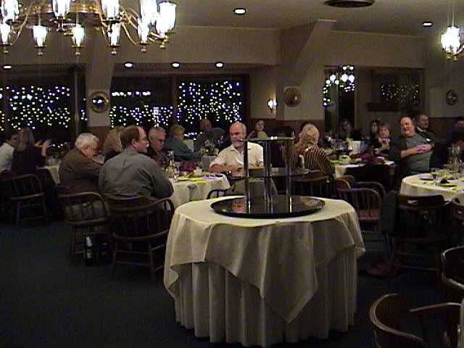
No this picture is not from "Close Encounters of the Third Kind"

It’s just that all of us in attendance at the San Joaquin Chapter of NDTA want you to know. If you have never been to the Port of Stockton for dinner or any of the other fine eating establishments we hold our meetings each month, then please come join us at the next Fund Raising Dinner. We might be here, there, or anywhere in the Greater San Joaquin Valley, but rest assure, we will be working hard and having fun, raising money for our annual Scholarship benefit. Our best resources are those we nurture for the challenges to come.

The moneys we raise go to deserving students who will become the vital links in our transportation industry. Check our some of those Scholarship Honor Students on our Web Site www.NDTA-SJ.COM
A Special Thanks to Our Hostess for the Evening.
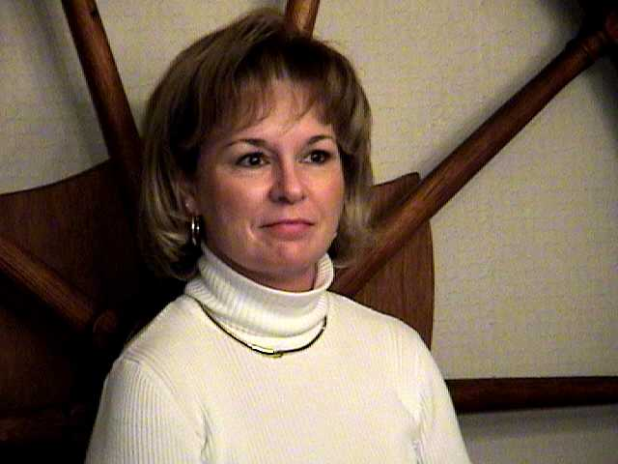
Dear Hostess, you were the mostess (is that a word?) Thank you!

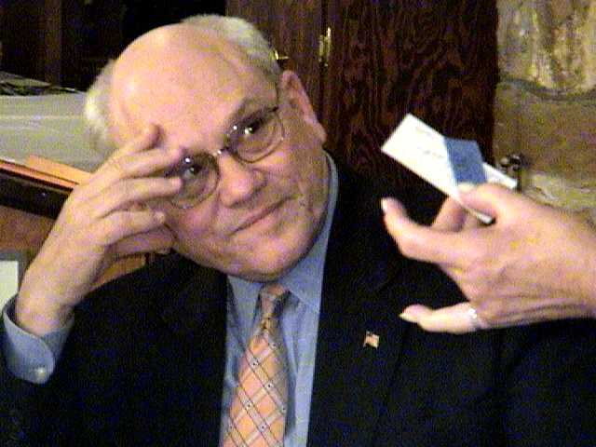

And please Mr. Boyanton, come again, this is your return ticket...We promise not to bite!!!!!!!!!

I’ll looking forward to our next meeting, provided that no one shoots the photographer,
PLEASE.....

William T. Brady, jr
Cargo Logistics, inc

